

NEF 3002 APPLIED PROJECT II

SEMESTER 2, BLOCK 2, 2023

VIRTUAL FRIEND

CHAT BOT

USER MANUAL



# AUTHOR: SUPERVISED BY:

Salon Thapa(s4662694) Dr. Sardar Farhad

[Salon.thapa@live.vu.edu.au](mailto:Salon.thapa@live.vu.edu.au)

Robinson Karki (s4670336) SUBMISSION DATE:

[Robinson.karki@live.vu.edu](mailto:Robinson.karki@live.vu.edu) 15TH September 2023

Table of Contents

AUTHOR: SUPERVISED BY: 1

**List Of Figures:** 3

**1.** **Introduction:** 1

**2.** **Data Flows:** 2

**3.** **Tools:** 2

**4.** **Installation:** 3

**5.** **Establish Project:** 5

**6. How to Use:** 7

**7. Troubleshooting** 11

**List Of Figures:**

Figure 1: Flow of Data. 2

Figure 2: Installation of Visual Studio. 3

Figure 3: Installation of PHP in Visual Studio. 3

Figure 4: Installation of java package. 4

Figure 5: Installation of OpenAI. 5

Figure 6: Installation of Xampp. 5

Figure 7: File location in Xammp folder in htdocs. 6

Figure 8: Opening folder in Visual Studio. 7

Figure 9: Creating database table in MYSQL. 7

Figure 10: Starting Apache and MYSQL. 8

Figure 11: Home page of Virtual Friend. 8

Figure 12: Register page of Virtual Friend. 9

Figure 13: Login Page of Virtual Friend. 9

Figure 14: Chat page Of Virtual Friend. 10

Figure 15: About Page of Virtual Friend. 10

Figure 16: Contact Page of Virtual Friend. 11

Figure 17: Query between user and chat bot. 11

Figure 18: Data file information. 12

Figure 19: Updating data file for troubleshooting. 12

Figure 20: Responses after Training data. 13

# **Introduction:**

Welcome to the personal virtual friend chatbot guide. The purpose of this comprehensive guide is to help both administrators manage the project and users to navigate and use this site effectively. In addition to practical instructions, this manual explains the basic algorithms behind the system, improving your understanding of its inner workings.

Personalized virtual friend chat represents a significant advance in artificial intelligence technology. It functions as a computer program designed to engage users in real-life conversations, providing companionship and personalized assistance. Unlike conventional chatbots that offer generic answers, our chatbot is a virtual companion designed to reflect certain traits, characteristics and even different personalities. This personalized approach ensures a unique and enriching interaction for each user.

As a system administrator, this guide provides you with the information you need to effectively manage and optimize your project. It is a valuable resource for users to explore the features and capabilities of our virtual friend chat room. Whether you're looking for companionship, help, or just an engaging conversation, our chat room is here to provide a personal and enriching experience. Dive into the guide and let's embark on this exciting journey together.

# **Data Flows:**

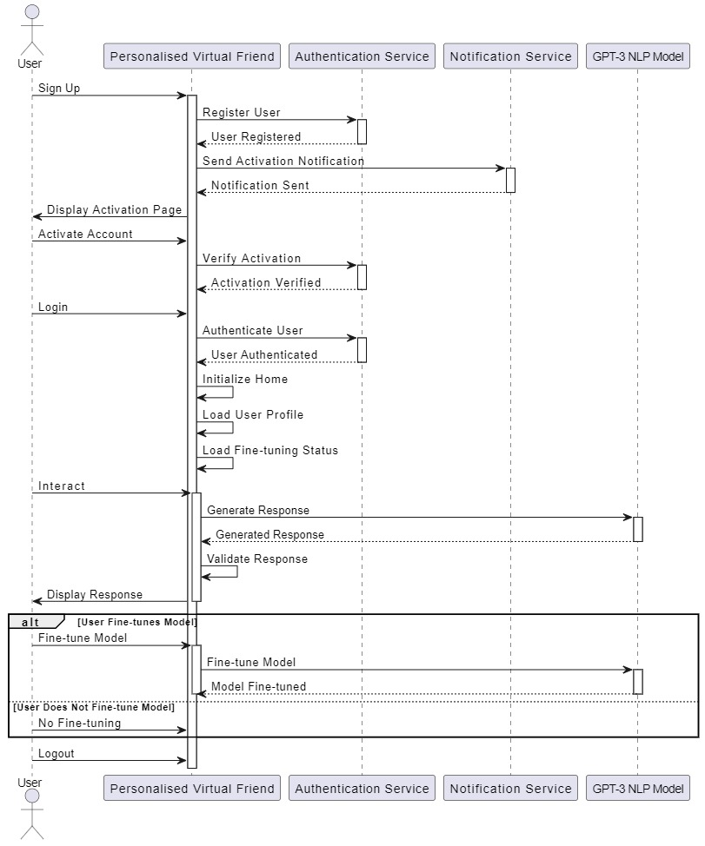

Figure : Flow of Data.

# **Tools:**

* 1. **Visual Studio code:** Visual Studio Code (VS Code) is a versatile, open-source code editor developed by Microsoft. It's designed for coding, debugging, and editing source code across various programming languages and platforms. With an extensive library of extensions, it can be customized to support different languages, frameworks, and tools, making it a preferred choice for developers. VS Code offers an integrated development environment (IDE) experience with features like code completion, Git integration, debugging, and an integrated terminal. It's cross-platform, meaning it works on Windows, macOS, and Linux, and it's known for its active community, regular updates, and adaptability to diverse coding needs.
  2. **Xampp:** XAMPP is a free, cross-platform software package used by web developers to create a local web server environment on their computers. It includes essential components like the Apache web server, MySQL database, and PHP/Perl scripting languages. Developers use XAMPP to build, test, and debug web applications offline before deploying them to live servers. It's a quick and convenient solution for local web development and is available for Windows, macOS, and Linux.

# **Installation:**

Step 4.1. Download Visual Studio Code from this given link [https://code.visualstudio.com/download](https://code.visualstudio.com/download%20) and select for your device. 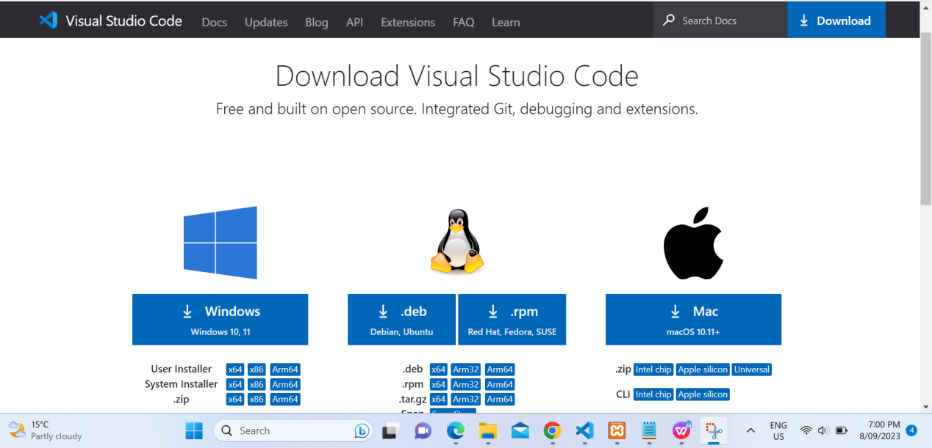

Figure : Installation of Visual Studio.

Step 4.2. Then download necessary extension for PHP.

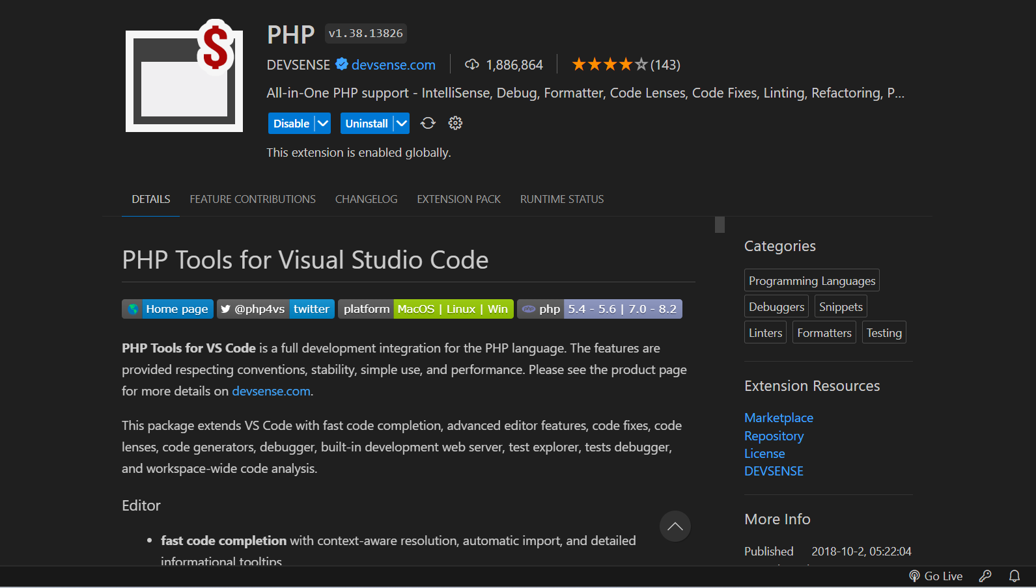

Figure : Installation of PHP in Visual Studio.

Step 4.3. And download extension and debugger pack for java as shown in pictures below.

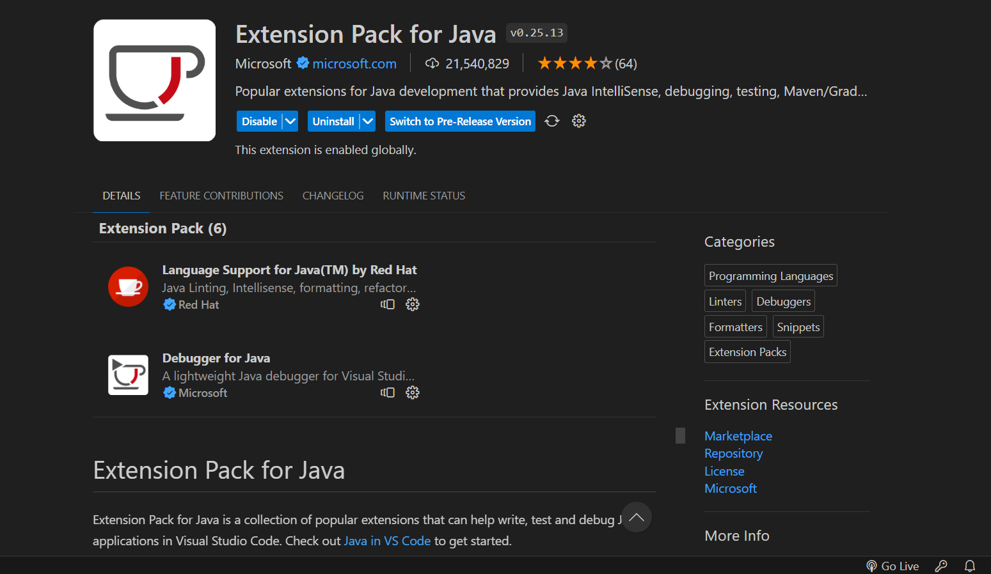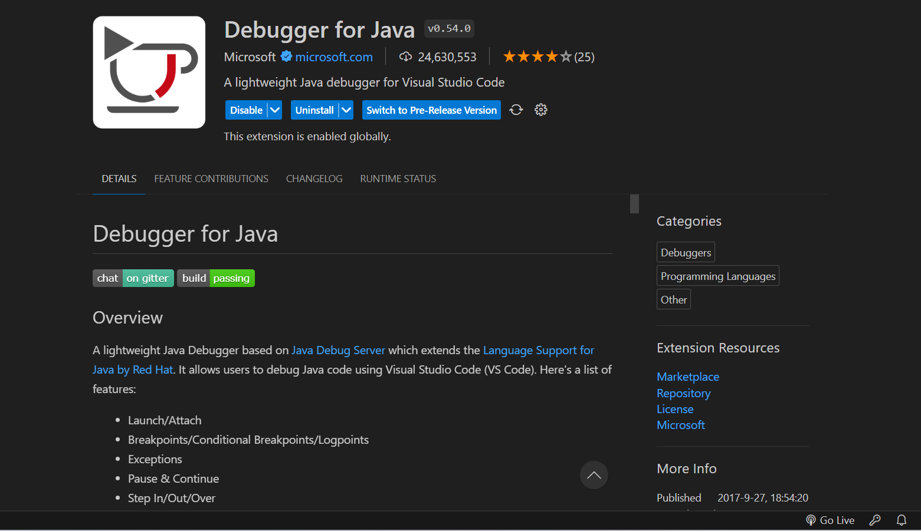

Figure : Installation of java package.

Step 4.4. Also run the command pip install OpenAI in virtual studio code.

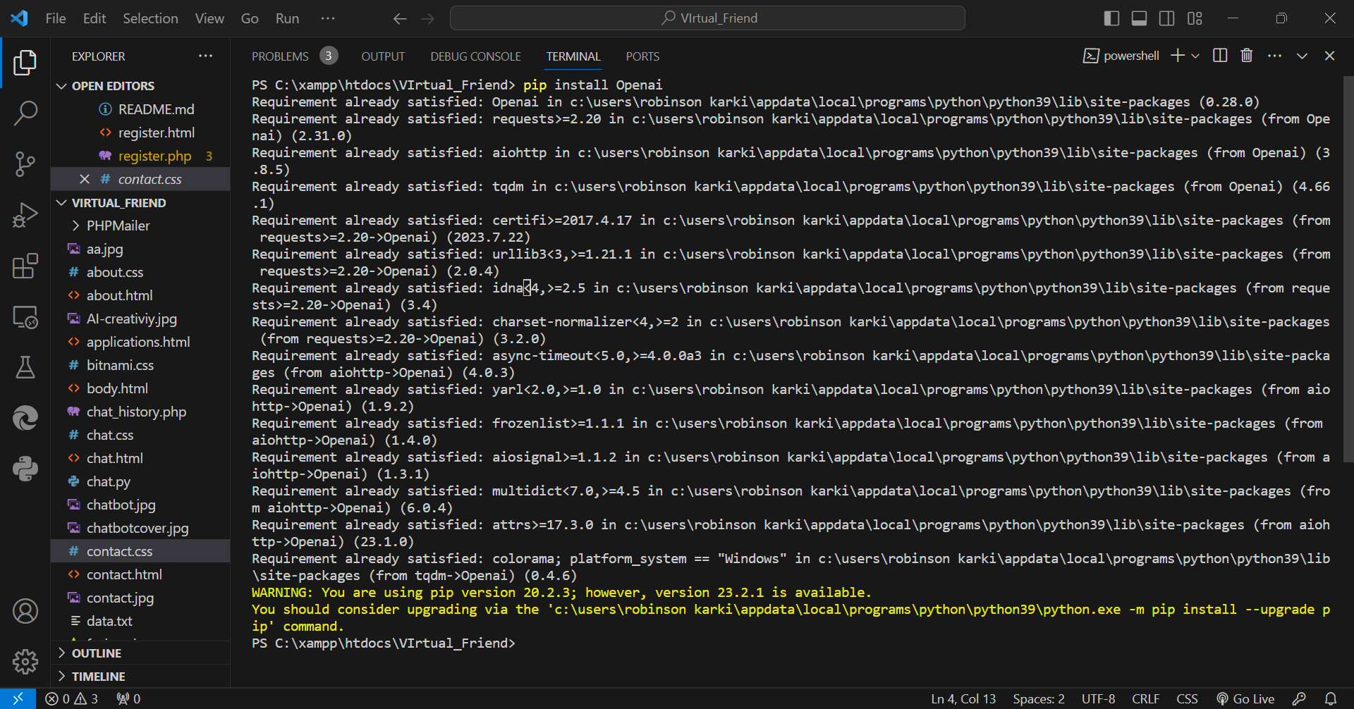

Figure : Installation of OpenAI.

Step 4.5. Download xampp from the given link: [Download XAMPP (apachefriends.org)](Download%20XAMPP%20(apachefriends.org))

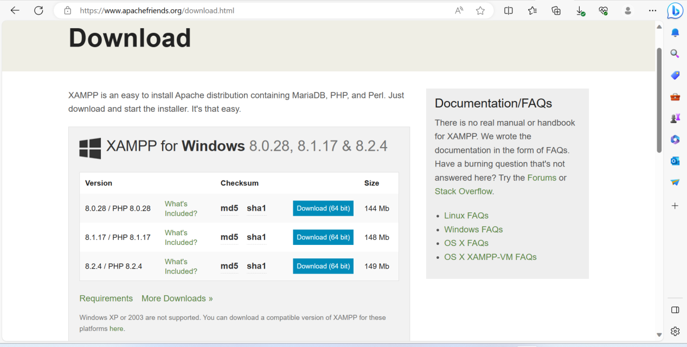

Figure : Installation of Xampp.

# **Establish Project:**

Step 5.1. Put all your files inside htdocs of xampp to run your website smoothly.

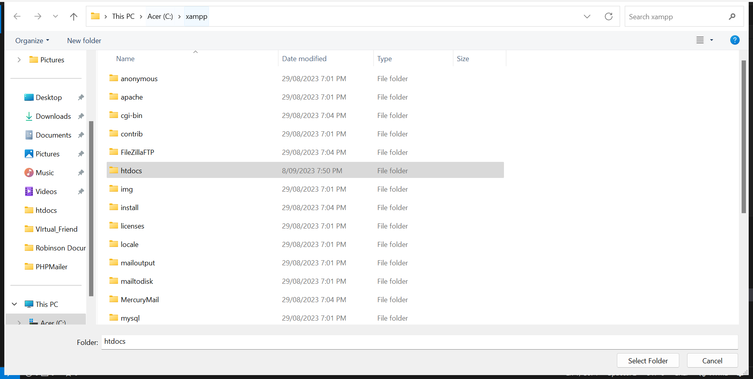

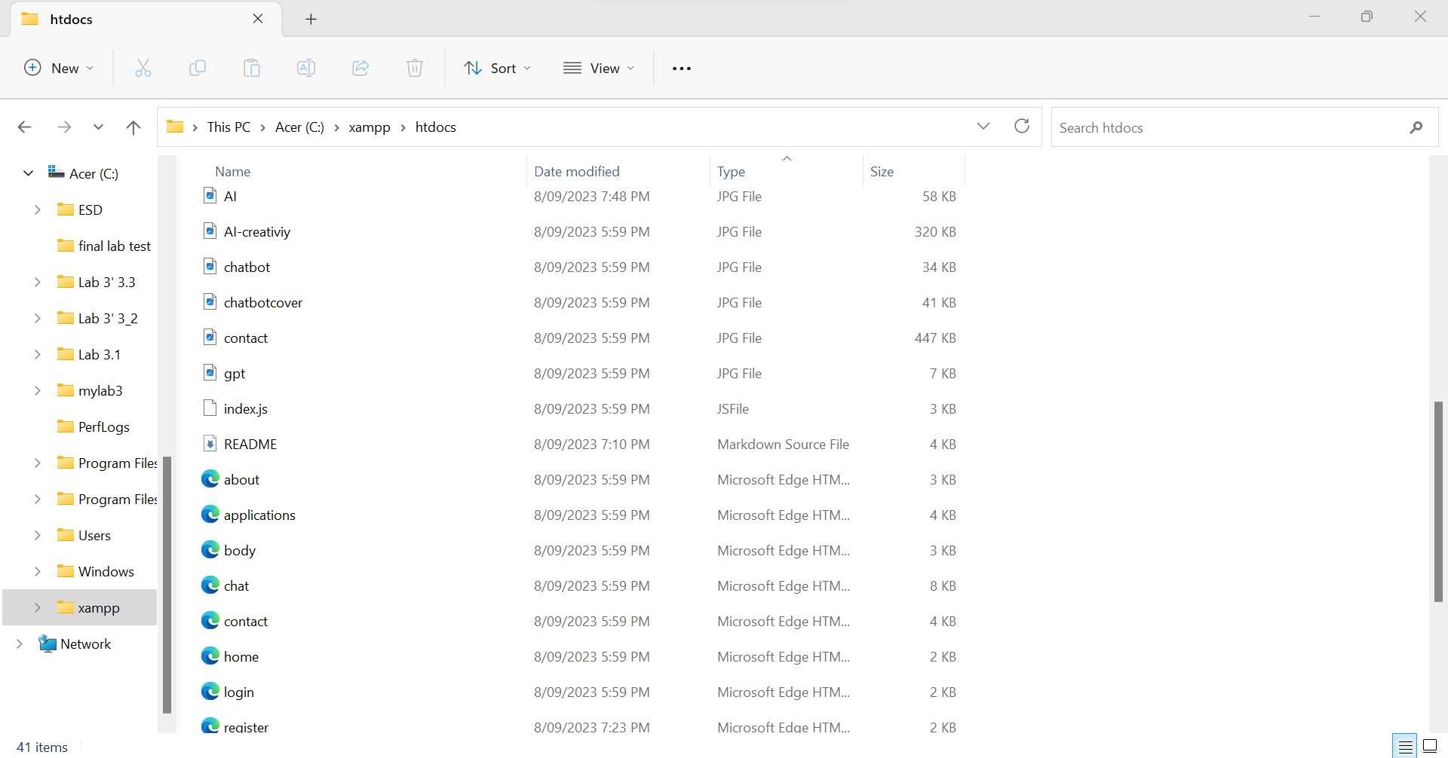

Figure : File location in Xammp folder in htdocs.

Step 5.2. You can see your folder in visual studio code when you select folder from htdocs of Xampp and you can view all your coded files.

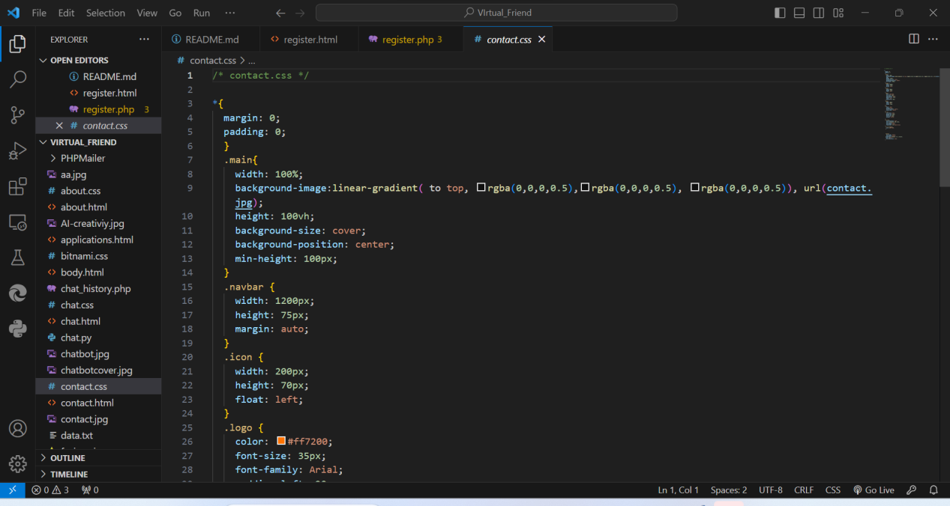

Figure : Opening folder in Visual Studio.

Step 5.3. Here we create a database containing 3 tables of email, password and activation-

token which is necessary to demonstrate our project.

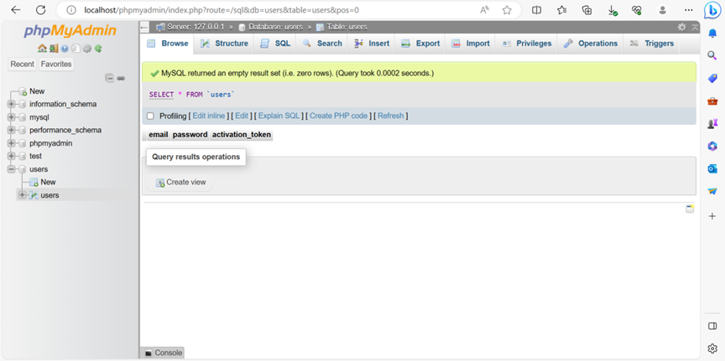

Figure : Creating database table in MYSQL.

**6. How to Use:**

Step 6.1. It is very necessary to start your xampp every-time to run or demonstrate this project/website.

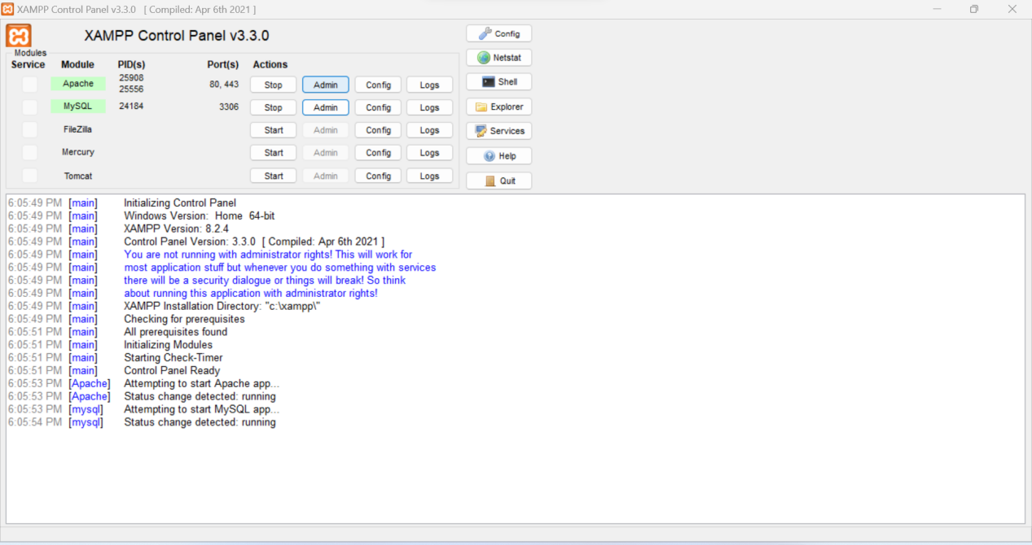

Figure : Starting Apache and MYSQL.

Step 6.2. This is the home page of project where it can be run through localhost/home.html in a browser.

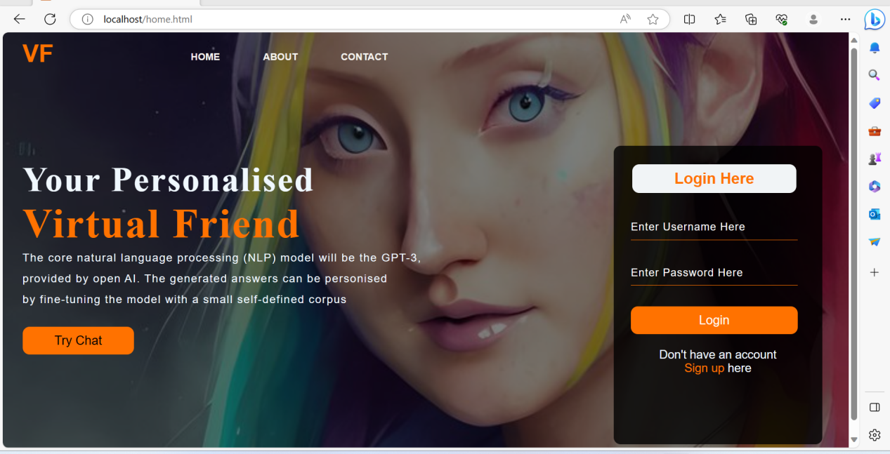

Figure : Home page of Virtual Friend.

From home page you can login, signup, try chat and know about our page/website and can contact to us via email.

Step 6.3. This is the register page of project where it can be run through localhost/register.html in a browser. You can register with your details in this page to interact with chatbot.

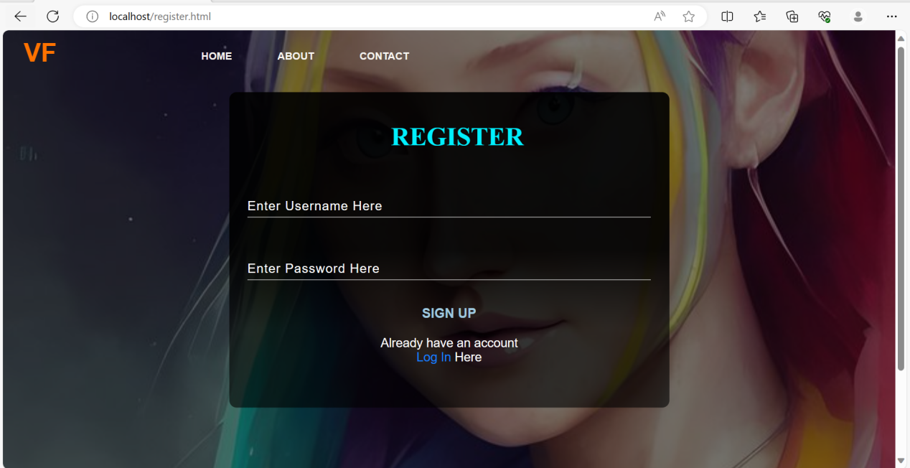

Figure : Register page of Virtual Friend.

Step 6.4. This is the login page of project where it can be run through localhost/login.html in a browser. You can login and chat with chat bot with your login details.

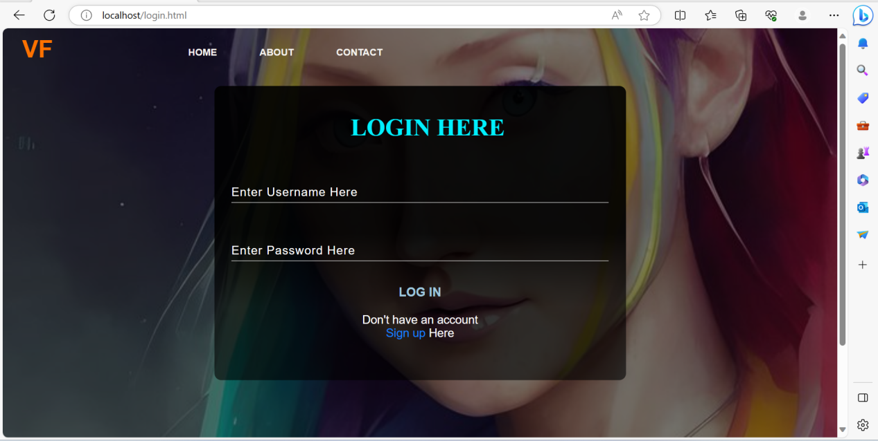

Figure : Login Page of Virtual Friend.

Step 6.5. This is the chat page of project where it can be run through localhost/chat.html in a browser. You can chat, interact and ask questions here. Also, you can use you own by choosing your file.

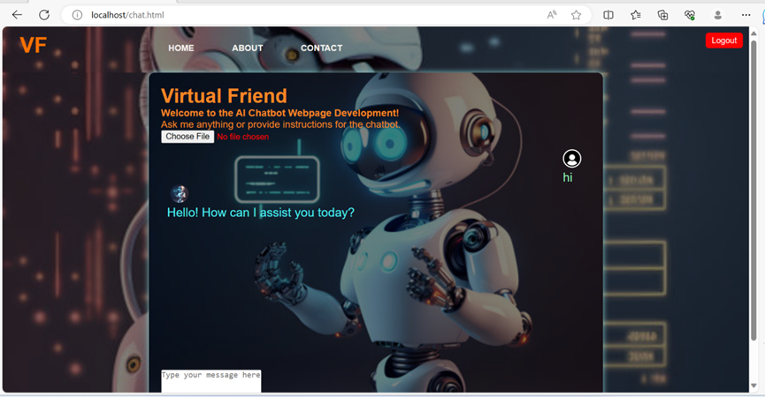

Figure : Chat page Of Virtual Friend.

Step 6.6. This is the about page of project where it can be run through localhost/about.html in a browser. This page is all about our created chatbot where we used chatgpt-3 model and its benefits.

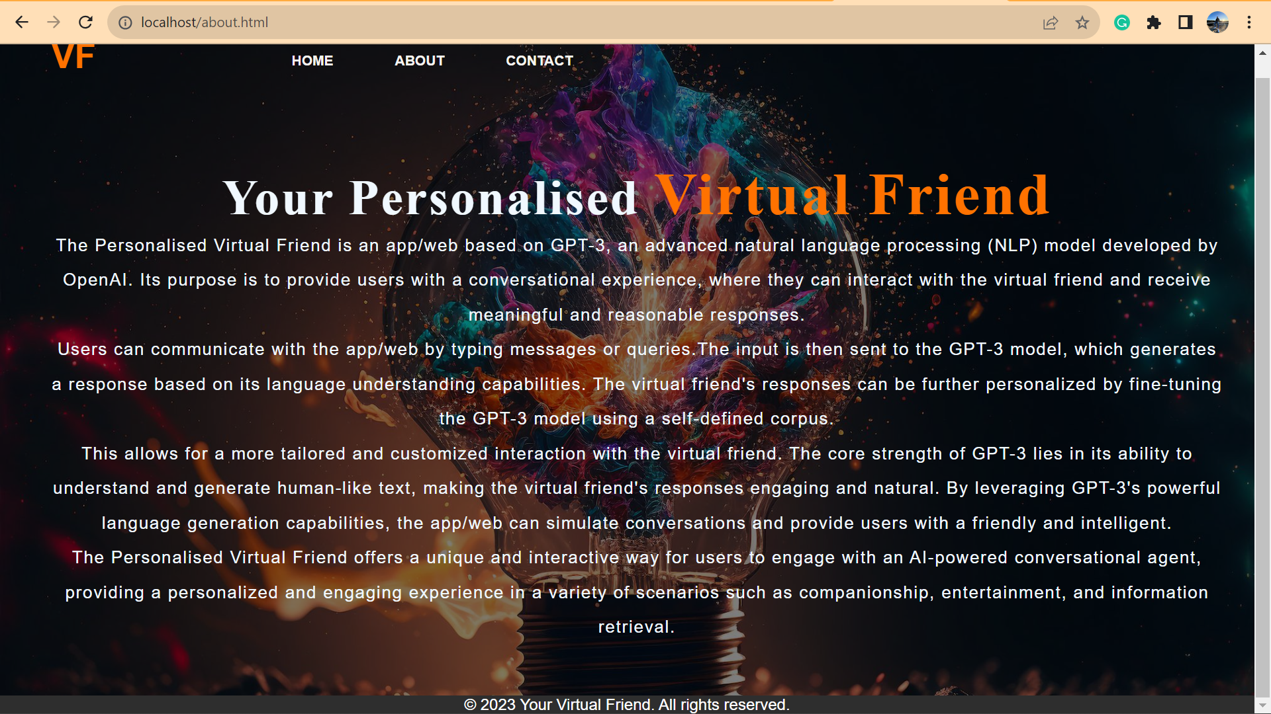

Figure : About Page of Virtual Friend.

Step 6.7. This is the contact page of project where it can be run through localhost/contact.html in a browser. In this page you can enter your username, email, leave comments and submit so that we can see about your query.

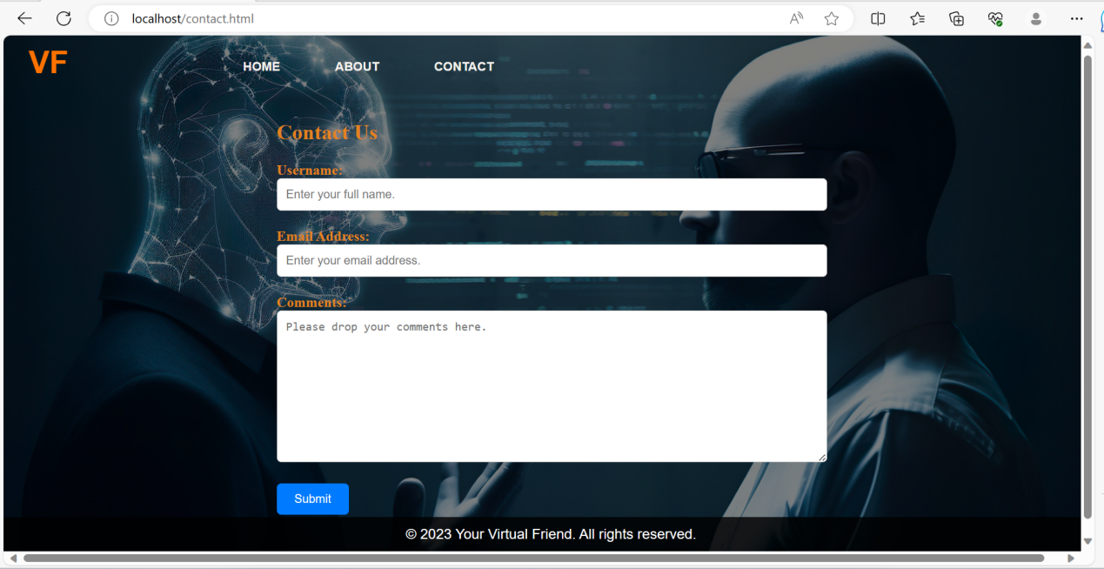

Figure : Contact Page of Virtual Friend.

# **7. Troubleshooting**

**Case one**

**Issue:** Users are not satisfied with the chatbot's responses. Or sometimes it will not response correctly. As I haven’t trained my data with sister’s name, so it didn’t response. So, in such case you must update to your data or trained data with required information because virtual friend chat bot is all about prompt data (prompt engineering)

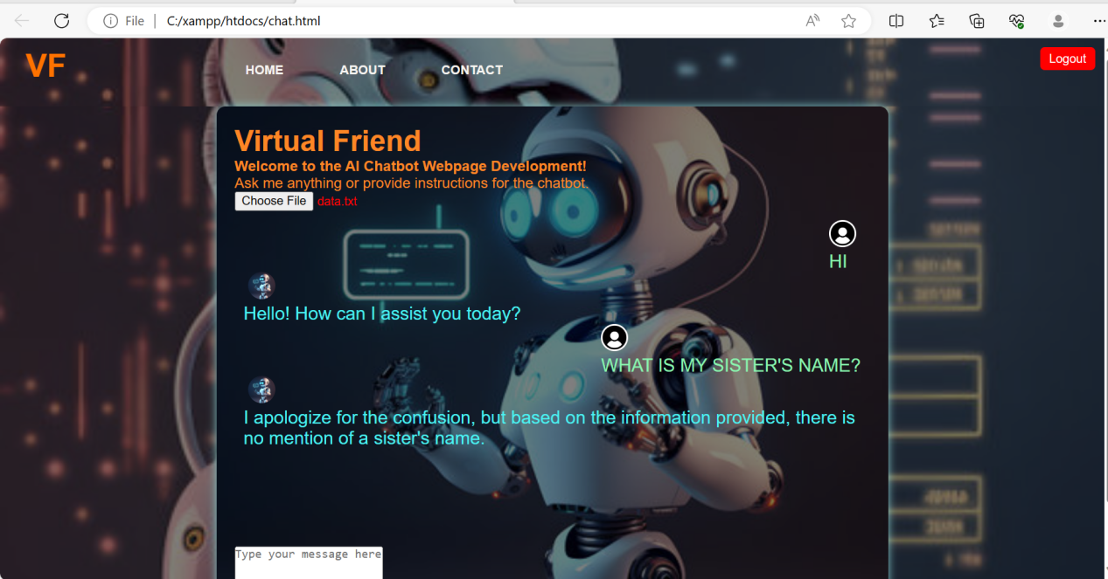

Figure : Query between user and chat bot.

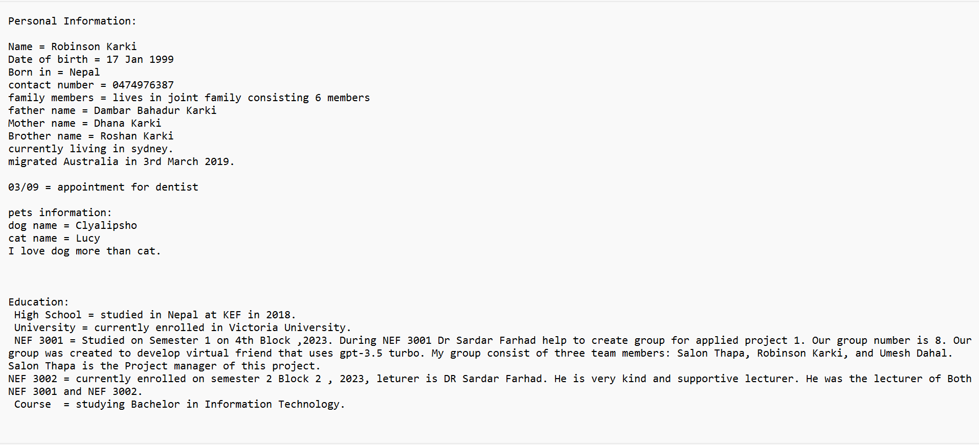

Figure : Data file information.

**Troubleshooting:** Collect user feedback and iterate on your chatbot's personality. And you should use correct and trained data to your chatbot.

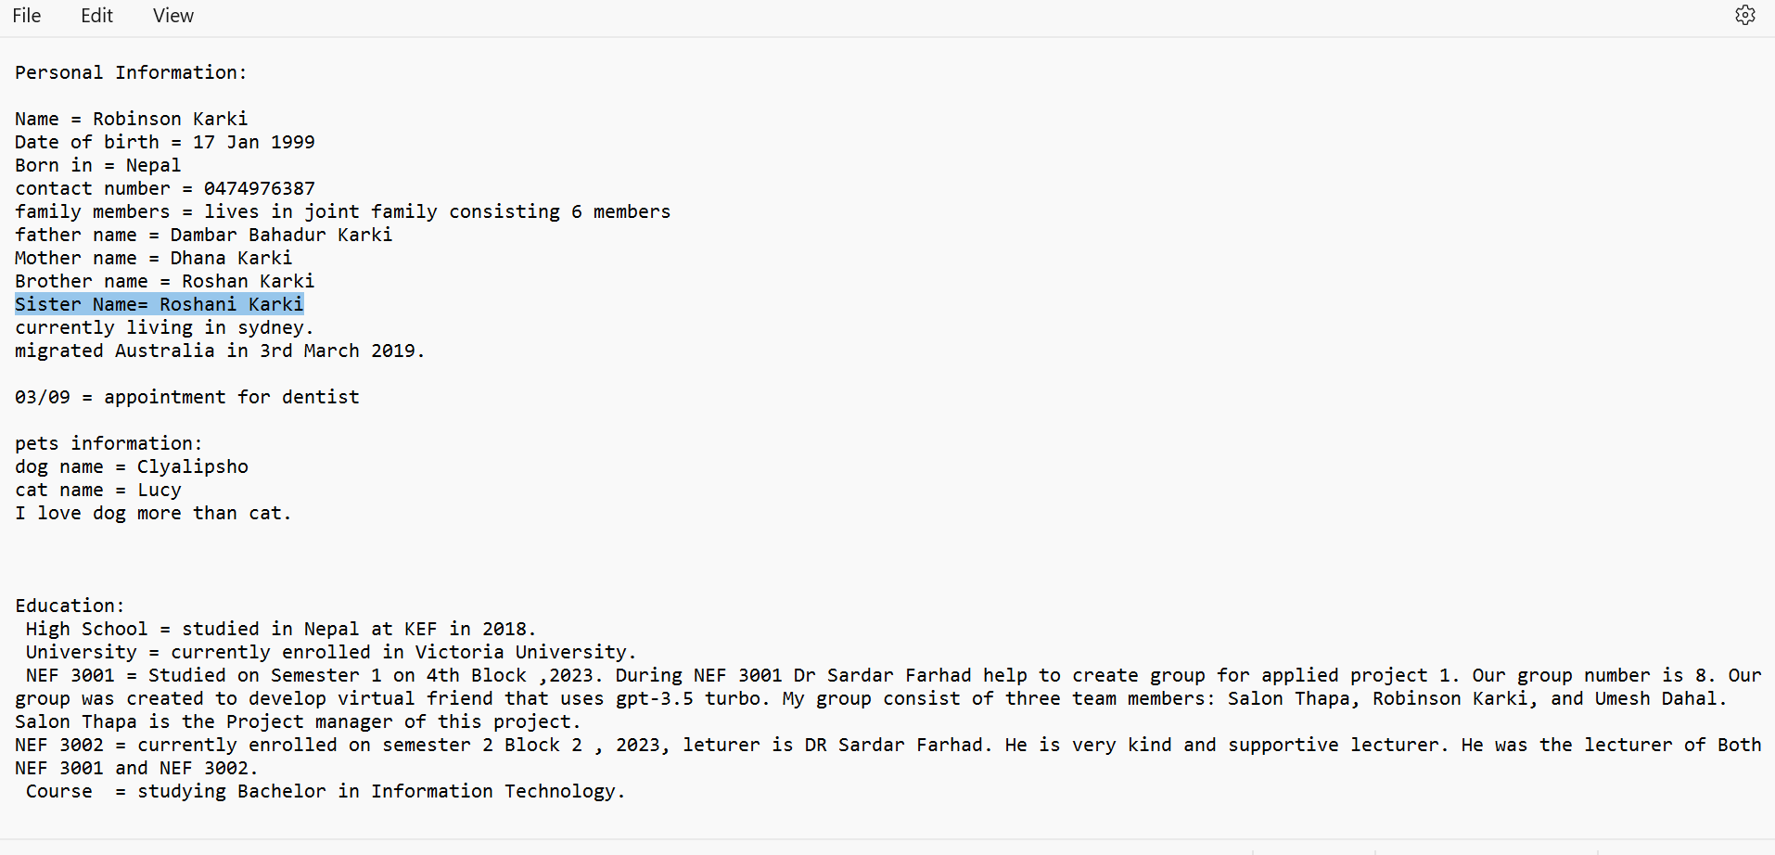

Figure : Updating data file for troubleshooting.

After training my data and choosing updated file it can response according to our questions.

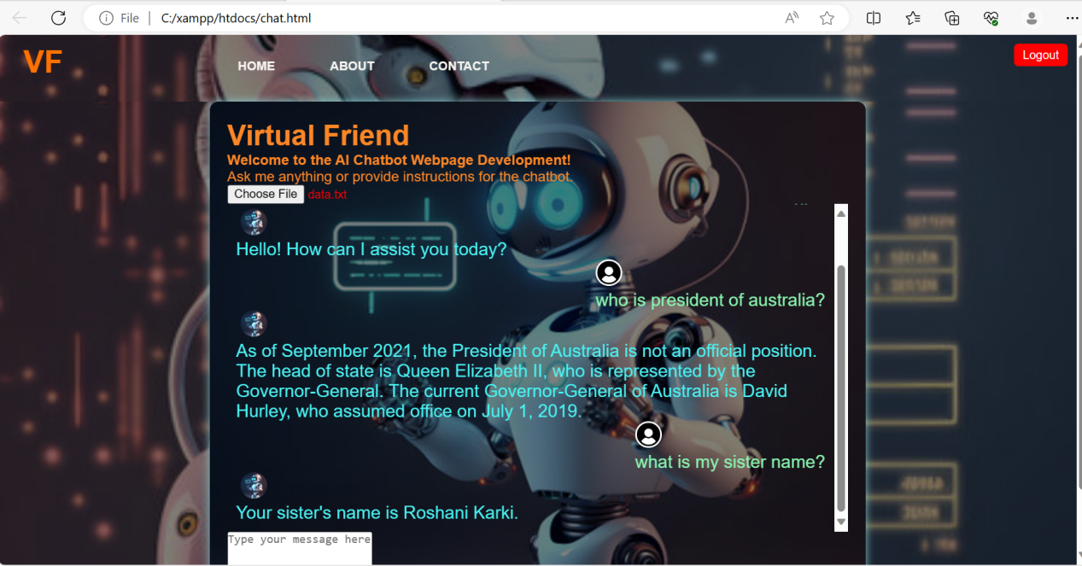

Figure : Responses after Training data.

The End!!!